**1. ReactJS-HOL**

1. Create a new React app, Install Nodejs and Npm .
2. Install Create-react-app by running the following command in the command prompt:

|  |
| --- |
| npm install -g create-react-app |

1. To create a React Application with the name of “myfirstreact”, type the following command:

|  |
| --- |
| npx create-react-app myfirstreact |

1. Once the App is created, navigate into the folder of myfirstreact by typing the following command:

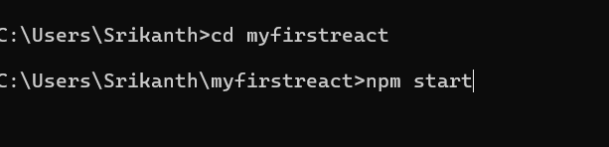

1. Open the folder of myfirstreact in Visual Studio Code
2. Open the App.js file in Src Folder of myfirstreact
3. Remove the current content of “App.js”
4. Replace with ..

|  |
| --- |
| App.js  import logo from './logo.svg';  import './App.css';  function App() {    return (      <div>        <h1>Welcome to the first session of React</h1>      </div>    );  }  export default App; |

1. Run the following command to execute the React application:

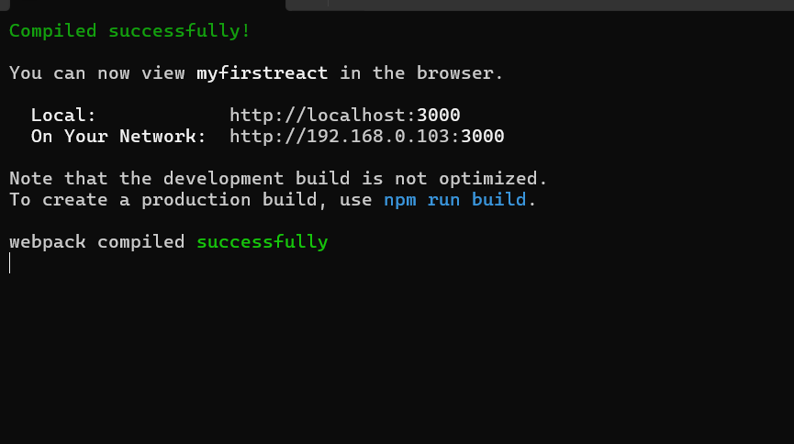

1. Open a new browser window and type “localhost:3000” in the address bar

